# Orbiter Mesh Tools for Blender – Simple Tutorial

January 31, 2016

For this tutorial we will use Blender and the Orbiter Mesh Tools plug-in to create a simple ‘cube’ vessel that uses an Orbiter vessel configuration file. This vessel will not do anything, but it will introduce you to some concepts needed to build a vessel mesh file using Blender and the Orbiter Mesh Tools plug-in.

Assumptions:

* Blender is installed.
* Orbiter Blender Plugin is installed.
* Orbiter is installed in C:\Orbiter.

## Create a Basic Mesh

Create a folder C:\MyShip. This will hold our .blend file and any other files we may need.

Start Blender. The default Blender scene is comprised of a cube mesh object, a camera, and a light. To keep things simple we will use the default cube as our initial object. You can remove the camera and light if you wish, but they will not interfere with our model so we will just leave them for now.

Before doing anything save the default Blender scene to your working folder. Select menu: *File » Save As*. Navigate to the *C:\MyShip* folder. Name the file *MyShip*. Blender will add the .blend extension. Your *MyShip.blend* file should now be in C:\MyShip. Before we can build the mesh file we need to set some properties.

Select the *Render Properties* panel (the *camera* icon circled in red) and open the *Orbiter Render Panel*.

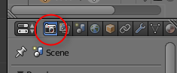

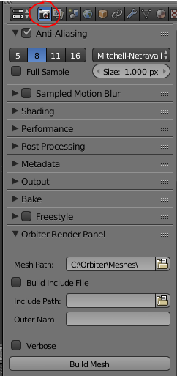

Set the Mesh Path: to *C:\Orbiter\Meshes*.

Un-check *Build Include File*.

In the Blender *Scene* drop-down at the top of the window, rename the scene from *Scene* to *MyShip*.



You’re now ready to build your first mesh file. Press *Build Mesh* to build the mesh file. If everything worked, you will see a *Build Mesh Done* message appear briefly at the top of the Blender window.

At this point you should have a very simple *MyShip.msh* file in your Orbiter *Meshes* directory. Orbiter Mesh Tools will build a separate mesh file for every scene in the .blend file. We have a single scene name *MyShip*, so we have just one mesh file.

Our ship will be based on a configuration file rather than a DLL so its functionality will be limited. We will setup the vessel configuration file next.

In *C:\Orbiter\Config\Vessels* create a new text file named *MyShip.cfg*.

Using Notepad (or any other text editor) edit *MyShip.cfg* and put the following lines in:

; === Configuration file for vessel MyShip ===

MeshName = MyShip

Size = 1

Save and close the config file.

Next we will need a scenario file that will use our ship. Our scenario will be very simple and will put our ship on a landing pad at Brighton Beach.

In *C:\Orbiter\Scenarios* create a new folder called *MyShip*.

Inside the new *MyShip* folder create a text file named *First.scn*. Edit *First.scn* in Notepad and enter the following:

BEGIN_DESC

MyShip parked at Brighton Beach

END_DESC

BEGIN_ENVIRONMENT

System Sol

Date MJD 52006.7491805055

END_ENVIRONMENT

BEGIN_FOCUS

Ship MyShip-01

END_FOCUS

BEGIN_CAMERA

TARGET MyShip-01

MODE Extern

POS 35.43 -21.13 -26.51

TRACKMODE TargetRelative

FOV 50.00

END_CAMERA

BEGIN_HUD

TYPE Surface

END_HUD

BEGIN_MFD Left

TYPE Launch

NAV 0

END_MFD

BEGIN_MFD Right

TYPE Map

REF Moon

BTARGET Brighton Beach

END_MFD

BEGIN_SHIPS

MyShip-01:MyShip

STATUS Landed Moon

BASE Brighton Beach:2

POS -33.4450804 41.1217033

HEADING 220.00

END

END_SHIPS

Save the scenario file.

We are now ready to run Orbiter and see our *Cube* ship at work.

Start Orbiter and load the *First* scenario we just created. You should see something like this:

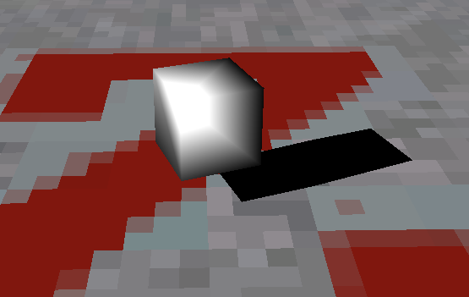

This is a good start, but it doesn’t look right. We will fix that next.

## Understanding Normals and Shading

Exit Orbiter and go back into Blender. We are going to edit our Cube object.

Select the cube (right click) and then press *[TAB]* to go into edit mode.

With your cursor over the 3D view port press *[N]* to toggle the *Object Settings* panel that appears on the right side of the 3D view screen. Scroll down the object settings panel until you see the *Normals:* setting as shown below:

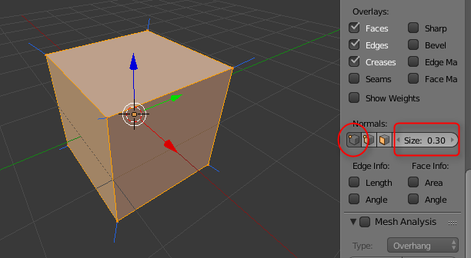

Select the first box which is *Vertex Normals* and increase the size to make them easier to see. The blue lines represent the settings for the vertices in the cube which by default will be an average of the faces of the cube. This makes for smooth shading from face to face and is why our ship looks odd. To create a hard edge in Blender you need to ‘split’ the edge. You can do that for each edge, or you can apply a modifier that will do it for you. The modifier is much easier so that’s what we will do.

Select the Blender *Modifiers* property window (the wrench circled in red below) and select *Add Modifier*. From the drop down menu select *Edge Split*. You should end up with a modifier window that appears below:

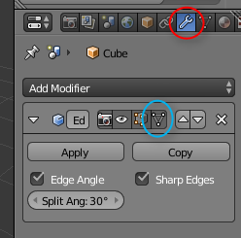

Click on the white triangle box circled in blue above to see the effects of the modifier on your cube:

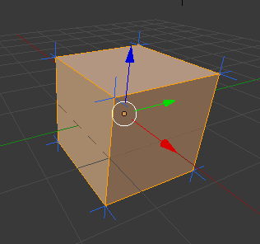

You will notice that each corner (vertex) now has three normals associated with it. This means the shading will ‘break’ at the edges rather than transition smoothly.

Object modifiers can be applied to an object, or left un-applied as we have done here. All modifiers will be applied when the mesh is built so a recommendation is to leave them un-applied while building your mesh as that will give you greater flexibility in modifying the effects it will have on your mesh.

Now, Save *[Ctrl-S]*, Build (Render panel, *Build Mesh*), and run Orbiter to see the results. You should get something like this:

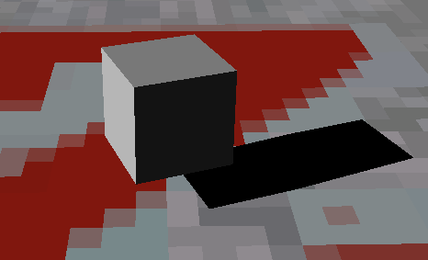

## Materials

Materials control various properties that effect how the render code interacts with an object. Textures, which we will discuss later, add visual detail. Materials in the plugin are handled in the *Materials* property panel:

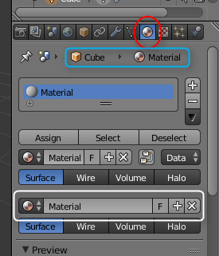

The panel shows the currently selected object and the material it is using (blue box).

In the box circled in white, change the name of this material from *Material* to *ShipMaterial*.

Scroll down the Materials property windows until you see the Orbiter Materials Panel:

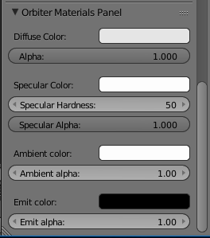

By default the Mesh Tools plugin will set Diffuse, Specular, and Ambient colors to white (full-on) and Emit to black (full-off). See the Orbiter SDK for a full discussion of these values.

Let’s change the color of our ship by changing the Diffuse Color to a slightly blue value. Do this by clicking on the ‘Diffuse Color’ color box and then selecting a color from the color wheel.

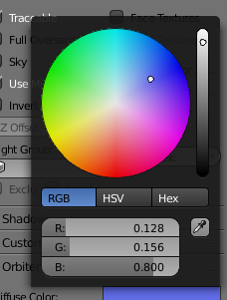

Save, build and run:

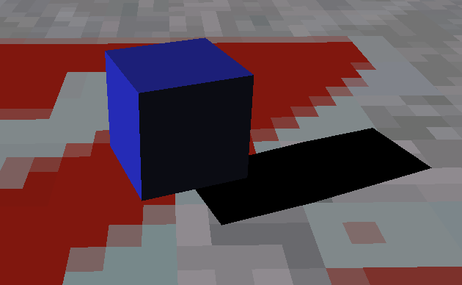

## Handling Transparency

Now we are going to add a second object that will be similar to a window on our vessel. To keep things simple we will add it as a *plane* above our cube.

If you have not already, exit Orbiter and go back to Blender. We are going to add a new object to our scene. Blender adds new objects at the location of the 3D cursor, which is the white and red circle in the 3D View.

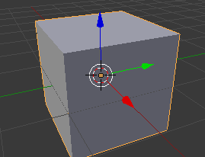

The cursor should be at the center of the X,Y,Z axis. If not, press *[SHIFT-S]* and from the *Snap* menu that appears select *Cursor to Center*.

Press *[SHIFT-A]* to add a new object. From the *Add* menu select *Mesh » Plane*. This will put a new Plane object in the middle of our cube.

Click on the blue *Z* axis arrow and drag it up until our plane object is just above our cube.

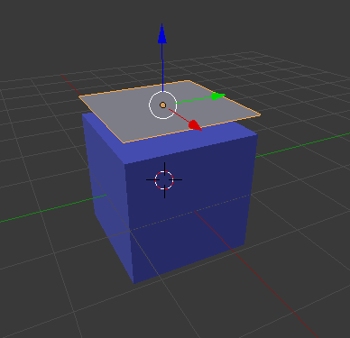

Now we are going to add a *Glass* material for this object.

Select the *Materials* property page and click on the *New* button to create a new material. In the material name type *Glass*.

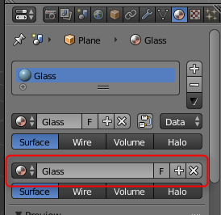

Scroll down to the Orbiter Materials Panel and select a light blue color for ‘Diffuse Color:’, then slide the Diffuse Color ‘Alpha’ selector to 0.5 (or thereabouts).

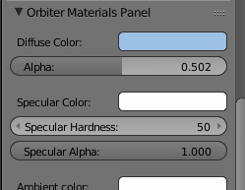

Now Save, Build and Run in Orbiter. You should see something like this:

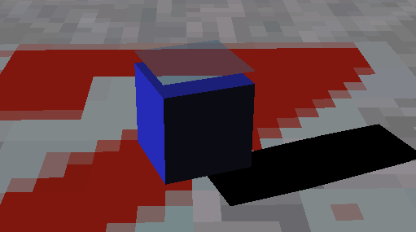

You will notice we are seeing the landing pad through the ship. This isn’t right. Objects that have transparency must be rendered after objects they may appear in front of. We can fix this by changing the sort order for the *Plane* object in the *Object Properties* panel in Blender.

Exit Orbiter and return to Blender.

Select the Plane by right-clicking on it. Then select the *Object Properties* (the box icon) in the Blender *Properties View*.

Scroll down to the *Orbiter Object Panel* and increase the *OrbiterSortOrder* to 51.

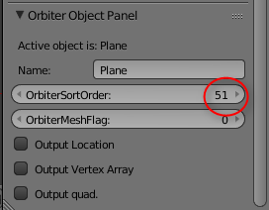

By default all objects are given an initial sort order of 50. If all of your objects are opaque this setting does not matter, but if you need to account for transparency this setting will allow you to control when an object is rendered.

Save, Build and Run in Orbiter. You should now see this:

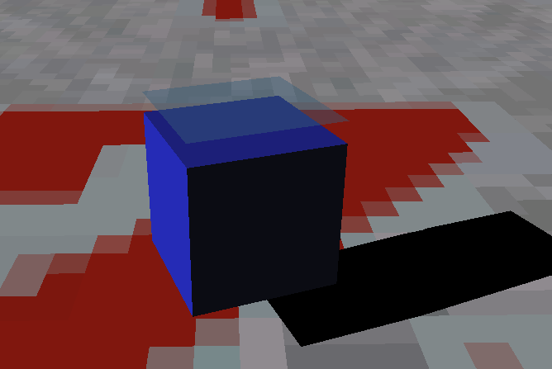

Better.

## Texturing

Adding a texture to an object gives it visual detail that cannot, or should not be added using modelling or materials. We will add a very simple texture to our cube that will indicate the top, bottom, front, back and sides of our cube vessel. To keep this walkthrough simple I have provided a simple texture to use. It’s called CubeShip.dds and should be in the same folder as this tutorial. To use it, copy it into C:\Orbiter\Textures.

If you are still in Orbiter, exit and return to Blender.

Unlike our model, which is 3D, a texture is only two dimensional, so we will need to ‘wrap’ the texture around our model. We do that by ‘un-wrapping’ our model so that the planes of the model can lay flat. This is called UV un-wrapping.

In Blender, select the cube (right-click), then press *[TAB]* to go into edit mode, and the press *[Z]* to go into wire-frame mode. You should see something like this:

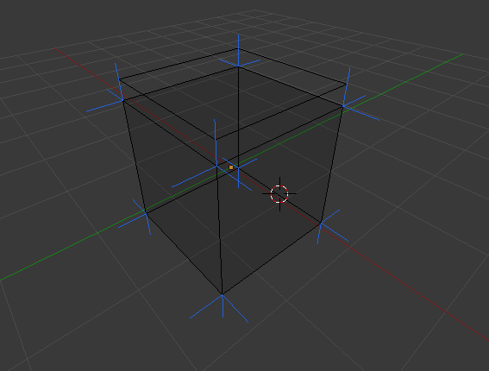

If you turned off the *Normals* display you won’t see the blue lines, it doesn’t matter for this.

In the tool bar below the window select the *edge select* mode, circled in red below:



We need to mark which edges are the ‘seam’ edges for our model. When we un-wrap our model, these are the edges that will separate in order for our model to lay flat.

Select the edges as shown below, holding down the *[Shift]* key to select multiple edges, then press *[Ctrl-E]* to bring up the *Edge* menu and select *Mark Seam*.

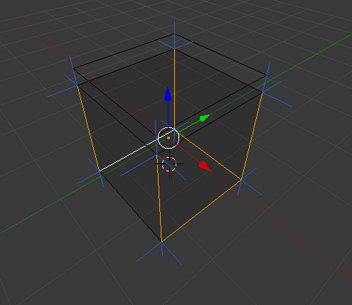

The seam edges should now be marked in red.

We now need to unwrap our model, and since you can unwrap only part of an object, we need to tell blender to unwrap the entire object. Press *[A]* twice to select the entire object. *[A]* is *select all* so basically you press *[A]* until your cube is all orange. Press the *[T]* key to open the *Tools* menu (should pop out of the left side of the screen) and select the *Shading / UVs* tab.

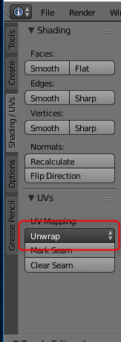

Select the *Unwrap* option (in red above) and from the menu that pops up select *Unwrap* again. You won’t see anything happen in the 3D window, to see the result of the unwrap operation change the window mode from *3D View* to *UV/Image Editor*. You do that selecting the window *mode* button (circled in red below) and selecting *UV/Image Editor* from the pop up menu.

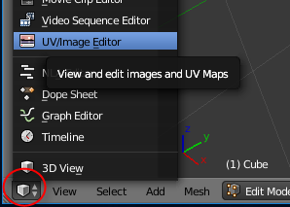

In the *UV/Image Editor* mode you should see the result of unwrapping our model.

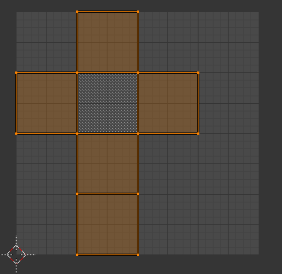

From the *UV* menu you can export this layout for use in a graphics application to create your ship texture. We won’t do that for this tutorial, instead we will use the provided *CubeShip.dds* file. If you haven’t done so already, copy it from the tutorial folder into *C:\Orbiter\Textures*.

To use the texture, select the *Texture* property window:

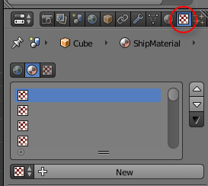

Click the *New* button to create a new texture and give it the name *CubeShipTexture*.

In the *Image* section select *Open* and select our texture file which should be C*:\Orbiter\Textures\CubeShip.dds.* Your *Texture* panel should look like this:

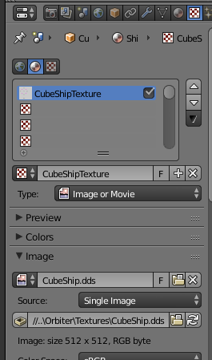

Finally, we need to select that texture for our UV texture. Select the option shown below, and select *CubeShip.dds*.

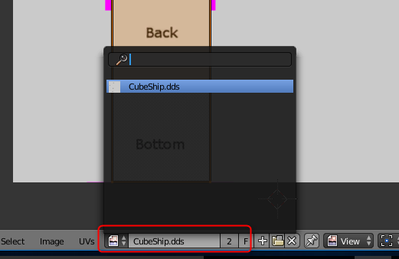

Your UV texture window should now look like this:

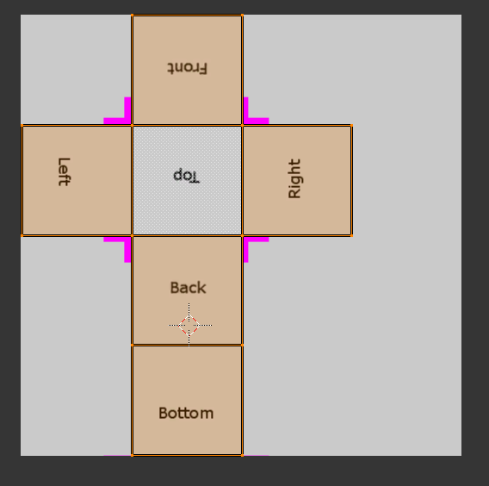

Before we build, go back to the *Materials* property and set the *Diffuse Color* back to white.

Now save, build, and then run in Orbiter, you should see this:

